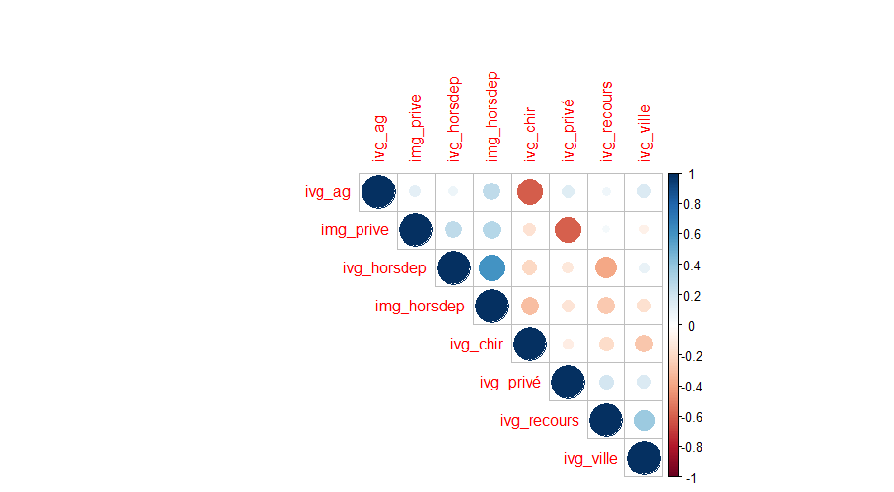

|  |  |  |  |  |
| --- | --- | --- | --- | --- |
|  | Classe 1 | Classe 2 | Classe 3 | Classe 4 |
| img_eta_prive | 2.53 | 4.97 | -0.131 | -4.77 |
| img_recours_ap22 | 2 | 0.479 | 3.08 | -4.64 |
| dens_nb_medg_2020 | 0.232 | 2.26 | 2.62 | -4.41 |
| img_recours.y | 1.53 | 0.596 | 2.96 | -4.33 |
| img_recours.x | 1.39 | 0.346 | 3.05 | -4.17 |
| ivg_eta_privÃ© | -0.00681 | 4.73 | 0.678 | -4.01 |
| img_recours_av22 | 1.1 | 0.596 | 2.44 | -3.56 |
| ivg_recours | -1.3 | 1.29 | 3.25 | -3.52 |
| img_prop_ap22 | 1.83 | 0.0166 | 2.27 | -3.38 |
| dens_nb_gynec_2020 | 0.634 | 1.62 | 1.66 | -3.2 |
| ivg_privÃ© | -0.848 | 7.41 | -1.72 | -2.94 |
| dens_nb_sgf_.2020 | 0.889 | -0.246 | 2.44 | -2.84 |
| ivg_chir | 5.77 | -1.35 | 0.402 | -2.73 |
| ivg_1314 | -0.456 | 0.273 | 2.29 | -2.29 |
| ivg_ville | -2.11 | 2.37 | -0.249 | -0.209 |
| ivg_ag | -8.08 | 1.93 | 1.76 | 1.4 |
| proxmat_2017 | -1.62 | 1.05 | -2.24 | 2.49 |
| img_prop_av22 | -1.83 | -0.0166 | -2.27 | 3.38 |
| img_prive | -1.46 | -6.19 | 0.518 | 4.63 |
| img_horsdep | -2.75 | -0.958 | -3.98 | 6.33 |
| ivg_horsdep | -1.93 | -1.29 | -5.41 | 7.58 |

